The Answer Is Right. Why Won’t the Model Stop?
On-policy distillation can punish a valid stopping decision when student and teacher prefer different end tokens
A model can solve a problem and still fail to stop. Repeated conclusions and abandoned corrections then consume its generation budget without adding useful reasoning. That is a costly distinction for developers transferring a teacher model’s capabilities to a student.
On-policy distillation, or OPD, trains on the student’s own responses. A fixed teacher evaluates the tokens it samples—the basic units a model uses to represent text. Supervision follows the student’s actual generation paths, but may mishandle how those paths should end.
Yuxiao Yang and colleagues identify a mismatch in End-of-Sequence (EOS) tokens: student and teacher can agree to stop while preferring different tokens to express it. Feedback can then punish a valid stopping decision. The opening figure separates finding the answer from finishing the response.
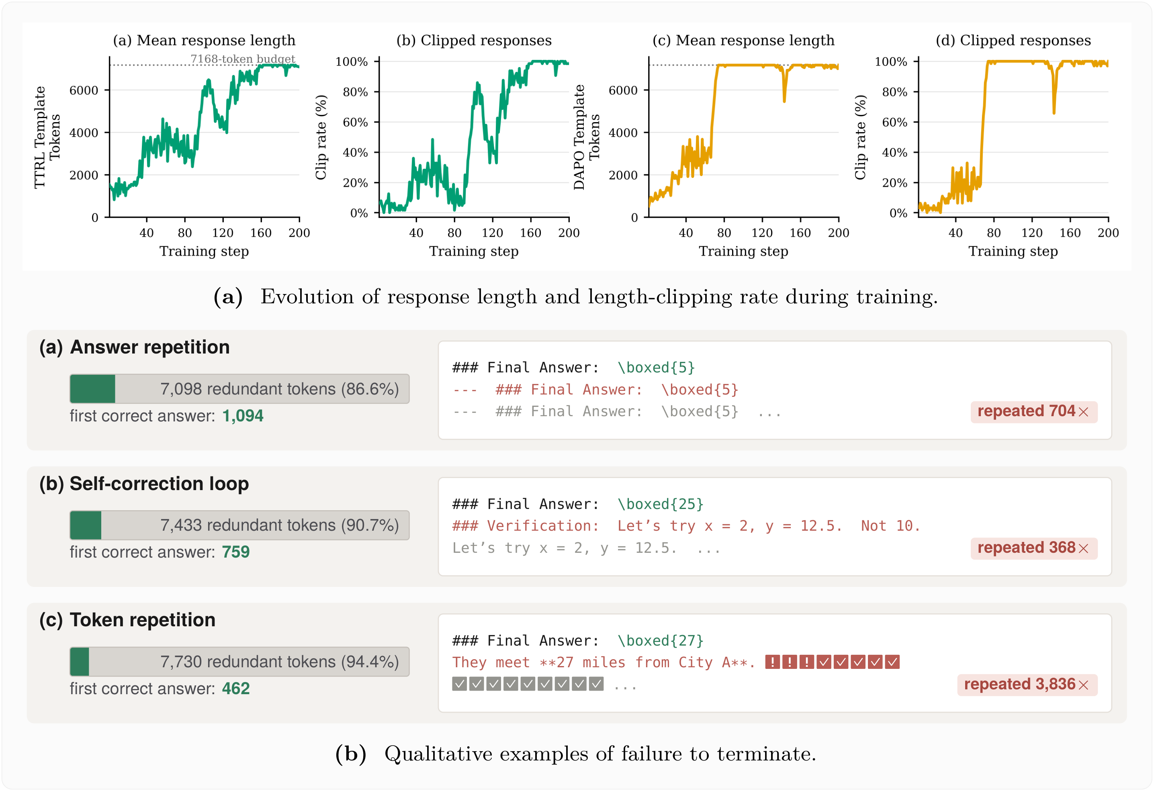
Figure 1. Longer output need not contain more reasoning. The paper’s Figure 1 plots Qwen3 response length and the share of responses reaching the generation limit, then illustrates continuations after an early correct answer. These are examples of a stopping failure, not dataset-wide averages.
Each illustrated response runs to 8,192 tokens. The first correct answers arrive at tokens 1,094, 759, and 462, leaving redundant continuations that account for 86.6%, 90.7%, and 94.4% of the respective responses. Those percentages describe individual failure cases. They are not average savings delivered by the proposed correction.
Paper: When EOS Tokens Disagree: Understanding Length Inflation in On-Policy Distillation
https://arxiv.org/abs/2609.20511
Code: https://github.com/UNCSciML/opd-eos
Project: https://uncsciml.github.io/opd-eos-website

One exit, different buttons
Think of equivalent EOS tokens as different buttons that open the same exit. The Qwen3 base student tends to press <|endoftext|>; its post-trained teacher prefers <|im_end|>. Sharing a tokenizer—the system that maps text to tokens—and a vocabulary does not make their learned preferences identical.
The study uses sampled-token OPD: the teacher evaluates the particular token the student chose. If the teacher gives that token less probability than the student does, the update suppresses it. That can happen to the student’s EOS even when the teacher strongly favors stopping through another token. The training signal sees a disagreement about the button where there may be agreement about leaving.
Learning the alternative is difficult, too. Around terminal states, the Qwen3 student assigns the teacher-preferred <|im_end|> a probability of about 10^-11. It almost never samples that token and therefore receives very little direct supervision on it. In the next figure, compare token preferences at the same student-generated prefixes; these curves are not accuracy scores.
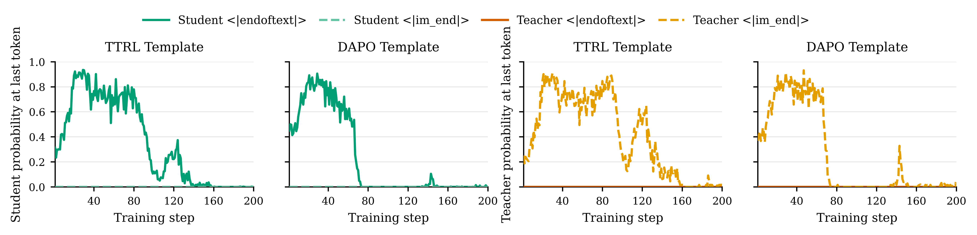
Figure 2. A mismatch in how models express termination. The paper’s Figure 2 measures token probabilities at the final position of each rollout, meaning a generated response, including both natural endings and budget-truncated responses. The student favors <|endoftext|> and the teacher <|im_end|>. Conditional token probabilities are not the fraction of responses that end naturally.
Under uncorrected Qwen3 OPD, the probability of the student’s native EOS drops from roughly 0.8 early in training to near zero as length and truncation increase. This fits the proposed mechanism: the familiar stopping action is repeatedly weakened, while the teacher’s alternative has almost no sampling support.

Fix the feedback, not just the decoder
The obvious intervention is to make the decoder stop on either token. The authors call this Fix 1. But changing what happens after a token appears neither makes it more likely to appear nor changes the feedback on the student’s chosen token. In Qwen3, this decoding-only intervention follows almost the same length and truncation trajectory as vanilla OPD.
Semantic EOS aggregation, labeled Fix 3, instead changes what the training objective compares. First identify the end tokens that really are equivalent under the generation protocol. Then, for both student and teacher, add their probabilities into one shared stop action. The relevant quantity is the total intention to stop, not the preferred surface token.
In plain notation, P(stop | current prefix) = the sum of probabilities of all equivalent EOS tokens. When the student samples any of them, the update compares the teacher’s and student’s log P(stop) and uses the gradient of the student’s log total stopping probability. The log-probability difference is held fixed when taking that gradient. Ordinary tokens keep their usual update, and the decoder must recognize every token in the equivalence class.
The study also tests two other probability-level corrections. Fix 2 collects the teacher’s termination probability on a canonical EOS already supported by the student. Fix 4 additionally removes the other equivalent EOS tokens from the student’s sampling space and renormalizes it. Fix 3 avoids choosing a canonical token, making it the default for the experiments across model families.

The evidence is about stopping, not universal accuracy gains
All models train on DAPO-Math-17K. The main pair is Qwen3-1.7B-Base as student and Qwen3-4B in non-thinking mode as teacher. Separate experiments use Llama-3.2-3B Base and Instruct, and Gemma-3-4B PT and IT—the pretrained and instruction-tuned versions. Each student–teacher pairing stays within its own family; this is not distillation between families.
Read the next figure through two measures: response length and clipping ratio, the share of responses that hit the generation-length limit. Gray reference lines describe teacher generations on the same prompts. These experiments use the TTRL prompt template, which requests step-by-step reasoning and a final answer inside \boxed{}. The Qwen3 panel also separates a decoder-only change from changes to the supervision itself.
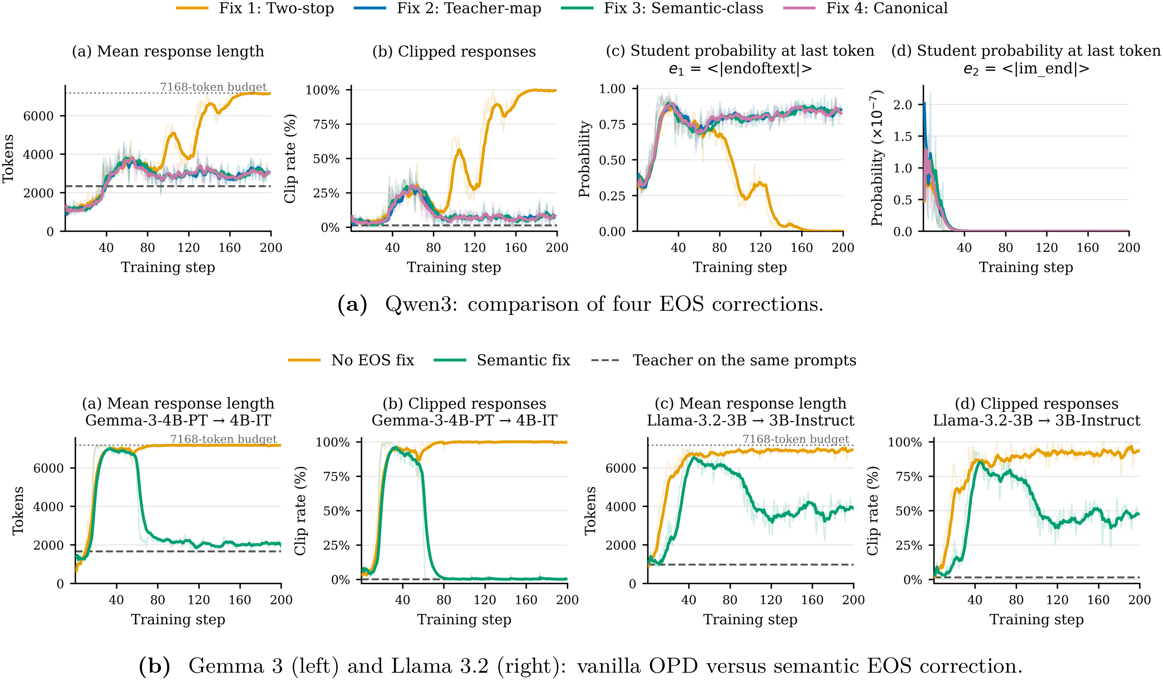
Figure 3. Aligning probabilities works better than expanding the stop list alone. In the paper’s Figure 4, Fix 2, Fix 3, and Fix 4 behave similarly on Qwen3 and keep length and clipping closer to teacher references than Fix 1. Semantic aggregation also mitigates inflation in Gemma 3 and Llama 3.2, with different recovery dynamics and residual gaps.
Corrected Qwen3 and Gemma 3 get relatively close to their teachers’ reference lengths; Llama 3.2 retains a larger gap. Gemma 3 is especially informative because student and teacher already declare the same EOS set. They nevertheless favor <eos> and <end_of_turn>, respectively. Matching configuration files is therefore not enough to ensure that training treats stopping consistently.
Reasoning performance is evaluated separately on AMC23, AIME24, and AIME25. Avg@16 averages correctness over 16 sampled responses per problem, then over problems within each benchmark, and finally over the three benchmarks with equal weight. It is not a measure that counts a problem as solved whenever any attempt succeeds. The paper finds no consistent mathematical-accuracy gain from correcting termination and supplies no exact cross-family average percentage saving to quote.
Evaluation can also change the apparent result without changing the model. In Qwen3’s DAPO-format evaluation, extending the answer parser to recognize equivalent LaTeX layouts moves the teacher’s measured Avg@16 from 6.28% to 24.34%. The normalization and exact-match correctness rule stay the same. This is a measurement correction, not a reasoning improvement or an accuracy gain from the EOS method.
Training and evaluation prompt templates also affect measured length and performance. That template analysis was conducted on Qwen3 and should not be assumed to generalize to the other families. Three questions need separate answers: did the model stop, did it solve the problem, and did the evaluator correctly extract its answer?

A diagnosis with a visible boundary
K2-Horizon-7B lets the authors test the limits of the explanation. They hold the final post-trained checkpoint fixed as teacher and initialize students from pretraining, midtraining, and supervised fine-tuning, or SFT. Unlike the Qwen3 case, the pretrained student already gives the teacher-preferred EOS a non-negligible probability. Vanilla OPD can transfer that surface form—but learning the right end token does not guarantee stable stopping later.
The next figure pairs length and clipping in the top row with end-token probabilities below. The important test is not only whether stopping recovers initially, but whether it remains stable. Even the semantically corrected run from the pretrained checkpoint develops renewed length inflation late in training.
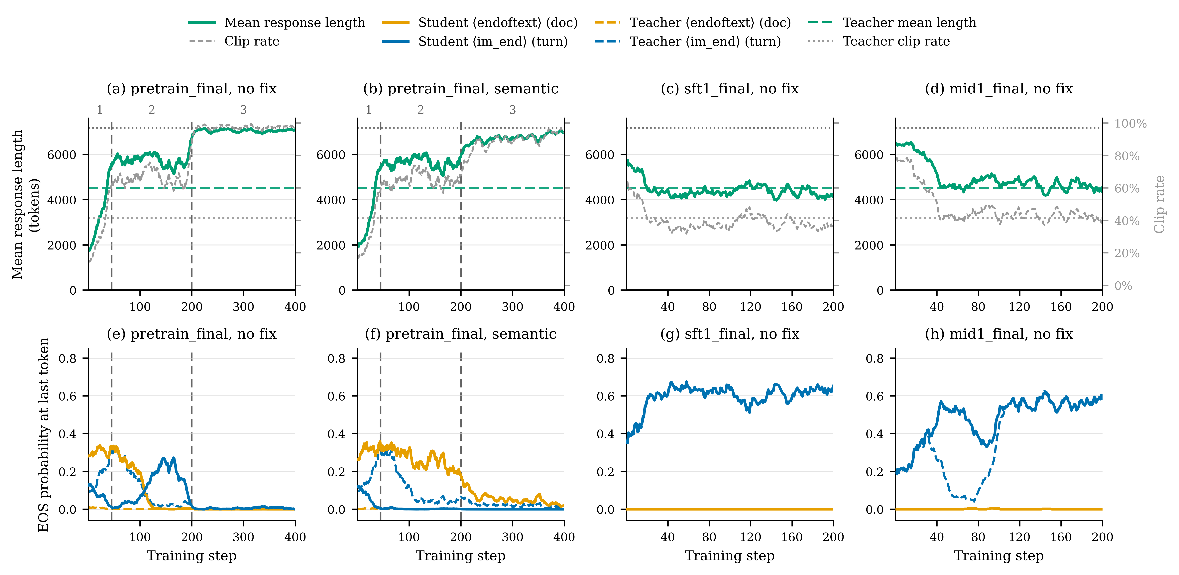
Figure 4. K2-Horizon exposes a remaining failure mode. The paper’s Figure 7 compares distillation from different training stages into the final model. The corrected pretraining initialization still re-inflates late in training, while midtraining and SFT initializations begin with preferences closer to the teacher’s. EOS mismatch is a cause of inflation, not a complete account of it.
The mechanism behind that late stopping collapse remains unresolved. An additional appendix control applies semantic aggregation to the already better-aligned midtraining and SFT checkpoints. Length, clipping, and accuracy remain broadly similar, with no consistent downstream degradation. That supports limited interference in these settings, not a guarantee for every training pipeline.

Check what “stop” means before diagnosing verbosity
The practical contribution is a way to break a vague symptom—distillation making a model increasingly verbose—into inspectable pieces: decoder configuration, learned token preferences, and the supervision signal. Compare student and teacher stopping probabilities at matched prefixes, then check whether training treats equivalent endings as competing actions. More generated text alone is not evidence of deeper reasoning.
The empirical scope is single-turn mathematics and sampled-token distillation; full-vocabulary OPD was not tested. In multi-turn conversations or tool use, message completion, the end of an assistant turn, and a tool handoff may mean different things and must not be merged indiscriminately. Aligning genuinely equivalent stopping actions mitigates one identifiable failure. It neither promises better reasoning nor removes every source of late-stage instability.

